-- How many cereals are available in the market are considered for analysis?

select distinct count(*) as Total_Cereals

from cereal ;

Screenshot 2024-06-19 125616 - Copy.png

-- How many manufactures focuses on producing Cereals?

select count(distinct Manufacturer) as Total_Manufactures

from cereal;

Screenshot 2024-06-19 125625 - Copy.png

-- Which manufactures produce cereals?

select distinct(Manufacturer)

from cereal;

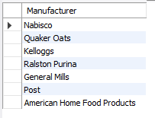

-- Which cereal has the highest rating?

select Name, Manufacturer, max(rating) as Rating

from cereal

group by Name, Manufacturer

order by rating desc

limit 1;

Screenshot 2024-06-19 125637 - Copy.png

-- Which cereal has the lowest rating?

select Name, Manufacturer, max(rating) as Rating

from cereal

group by Name, Manufacturer

order by rating asc

limit 1;

Screenshot 2024-06-19 125637 - Copy.png

-- How many different products are produced by each brands/manufactures grouped by their serving type?

select Manufacturer, Serving_Type as 'Serving Type', count(Manufacturer) as Total_products

from cereal

group by Manufacturer, Serving_Type;

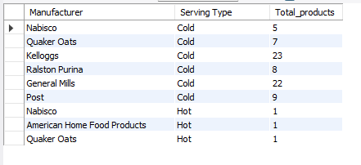

-- What are the types of servings in cereals available in the market?

select count(distinct Serving_Type) as 'Serving Types'

from cereal;

Screenshot 2024-06-19 125637 - Copy.png

-- How many cereals are available in each type?

select Serving_Type as 'Serving Types', count(Name) Products

from cereal

group by Serving_Type;

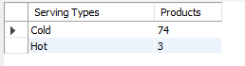

-- Which cereal has the highest calorie in one serving?

select Name, Manufacturer, calories

from cereal

order by calories desc

limit 1;

Screenshot 2024-06-19 125637 - Copy.png

-- Is there any cereal which provides the minimum calorie included in one meal?

SELECT Name

FROM cereal

where calories = 200 ;



-- Which cereal has the highest Carbohydrate in one serving?

select Name as 'Cereal with Highest Carb', carbo

from cereal

order by carbo desc

limit 1 ;

Screenshot 2024-06-19 125637 - Copy.png

-- Which cereal has the Lowest Carbohydrate in one serving?

select Name as 'Cereal with Lowest Carb', carbo

from cereal

order by carbo

limit 1 ;



-- Top 10 cereals with Highest rating

select *

from cereal

order by rating desc

limit 10;

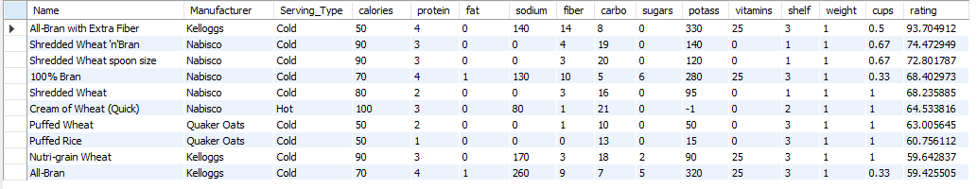

-- Top 10 cereals with Lowest rating

select *

from cereal

order by rating

limit 10;

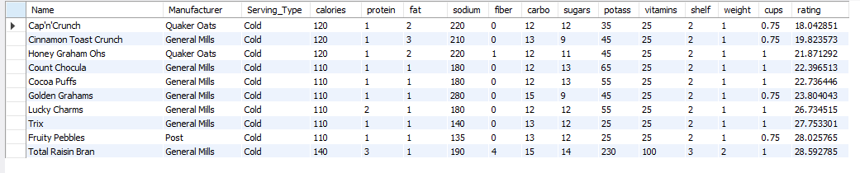

-- What is the Maximum level of sodium content available in cereals?

select max(sodium) as 'Highest Sodium'

from cereal ;



-- What is the minimum level of sodium content available in cereals?

select min(sodium) as 'Lowest Sodium'

from cereal ;



-- Which cereal contains the maximum fiber content?

select Name

from cereal

order by fiber desc

limit 1;



-- Which cereal contains the minimum fiber content?

select Name

from cereal

order by fiber

limit 1;



-- Top 10 cereals with Highest protein

select Name, Manufacturer, round(rating,2) as Rating

from cereal

order by protein desc

limit 10;

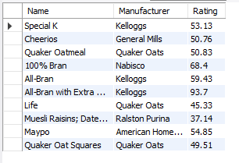

-- Top 10 cereals with Lowest protein

select Name, Manufacturer, round(rating,2) as Rating

from cereal

order by protein

limit 10;

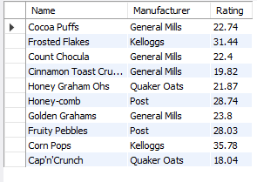

-- Top 10 cereals with Highest Fat

select Name, Manufacturer, round(rating,2) as Rating

from cereal

order by fat desc

limit 10;

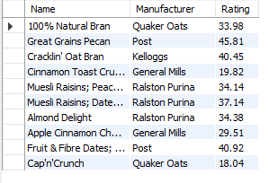

-- Top 10 cereals with Lowest Fat

select Name, Manufacturer, round(rating,2) as Rating

from cereal

order by fat

limit 10;

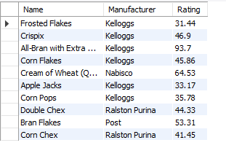

-- Top 10 cereals with Highest Sugar

select Name, Manufacturer, round(rating,2) as Rating

from cereal

order by sugars desc

limit 10;

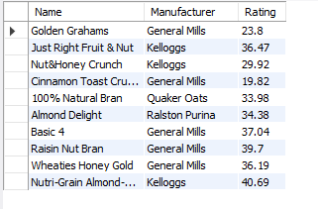

-- Top 10 cereals with Lowest Sugar

select Name, Manufacturer, round(rating,2) as Rating

from cereal

order by sugars

limit 10;

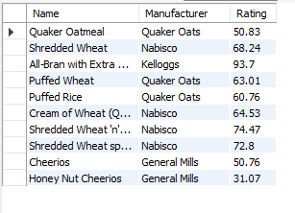

-- Top 10 cereals with Highest Fiber

select Name, Manufacturer, round(rating,2) as Rating

from cereal

order by fiber desc

limit 10;

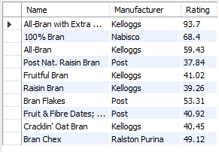

-- Top 10 cereals with Lowest Fiber

select Name, Manufacturer, round(rating,2) as Rating

from cereal

order by fiber

limit 10;

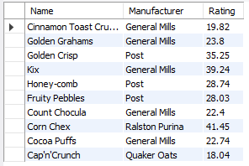

-- How many products are stored in Top shelf?

select count(name) as 'Number of products in Top shelf'

from ( select name, mfr

from cereal

where shelf = 3 ) a;

C:\Users\hp\OneDrive\Documents\My Works\Breakfast Cereals Analysis\results\Screenshot 2024-06-19 132240.png

-- Which cereals have High vitamins and minerals prescribed by FDA

select name as 'Cereals with Highest Vitamins', Manufacturer, round(rating,2) as Rating

from cereal

where vitamins=100;

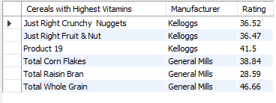

-- how many cereals have an in each fiber_source?

With table2 as

( select *, round((fat/calories)*100,2) as 'perc_fat_in_calorie',

if (sodium >= 500,'High', if (sodium <= 140, 'Low', if (sodium = 0,'No Sodium','Good'))) as sodium_status,

if (fiber > 4.9, 'Excellent', if (fiber < 2.4, 'Good', 'Average')) as fiber_source,

if (potass > 500, 'High', if (potass between 300 and 500, 'Safe', 'Less')) as potass_status

from cereal )

select fiber_source, count(Name) as 'Total Products'

from table2

group by fiber_source ;



-- Is there any cereals have sodium content exceeding the health guidelines?

With table2 as

( select *, round((fat/calories)*100,2) as 'perc_fat_in_calorie',

if (sodium >= 500,'High', if (sodium <= 140, 'Low', if (sodium = 0,'No Sodium','Good'))) as sodium_status,

if (fiber > 4.9, 'Excellent', if (fiber < 2.4, 'Good', 'Average')) as fiber_source,

if (potass > 500, 'High', if (potass between 300 and 500, 'Safe', 'Less')) as potass_status

from cereal )

select Name

from table2

where sodium_status = 'High' ;



-- How many products have a safe level of Potassium content?

With table2 as

( select *, round((fat/calories)*100,2) as 'perc_fat_in_calorie',

if (sodium >= 500,'High', if (sodium <= 140, 'Low', if (sodium = 0,'No Sodium','Good'))) as sodium_status,

if (fiber > 4.9, 'Excellent', if (fiber < 2.4, 'Good', 'Average')) as fiber_source,

if (potass > 500, 'High', if (potass between 300 and 500, 'Safe', 'Less')) as potass_status

from cereal )

select Name, Manufacturer, potass, potass_status

from table2

where potass_status = 'Safe';

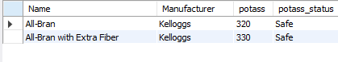

-- How many products are following the health guidelines in terms of sodium, potassium and fiber content?

With table2 as

( select *, round((fat/calories)*100,2) as 'perc_fat_in_calorie',

if (sodium >= 500,'High', if (sodium <= 140, 'Low', if (sodium = 0,'No Sodium','Good'))) as sodium_status,

if (fiber > 4.9, 'Excellent', if (fiber < 2.4, 'Good', 'Average')) as fiber_source,

if (potass > 500, 'High', if (potass between 300 and 500, 'Safe', 'Less')) as potass_status

from cereal )

select *

from table2

where sodium_status = 'Good' and fiber_source = 'Excellent' and potass_status = 'Safe';



-- How many products are lacking in terms of sodium, potassium and fiber content?

With table2 as

( select *, round((fat/calories)*100,2) as 'perc_fat_in_calorie',

if (sodium >= 500,'High', if (sodium <= 140, 'Low', if (sodium = 0,'No Sodium','Good'))) as sodium_status,

if (fiber > 4.9, 'Excellent', if (fiber < 2.4, 'Good', 'Average')) as fiber_source,

if (potass > 500, 'High', if (potass between 300 and 500, 'Safe', 'Less')) as potass_status

from cereal )

select *

from table2

where sodium_status = 'Low' and fiber_source = 'Average' and potass_status = 'Less' ;

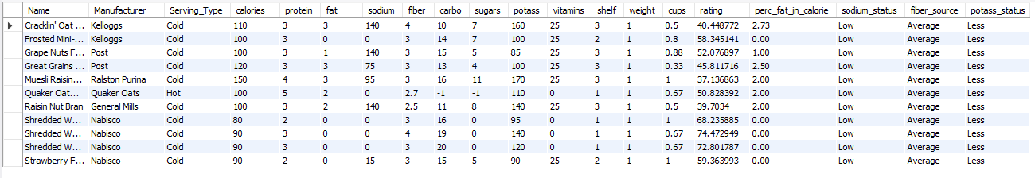

-- What is the highest percentage of fat included in calorie?

With table2 as

( select *, round((fat/calories)*100,2) as 'perc_fat_in_calorie',

if (sodium >= 500,'High', if (sodium <= 140, 'Low', if (sodium = 0,'No Sodium','Good'))) as sodium_status,

if (fiber > 4.9, 'Excellent', if (fiber < 2.4, 'Good', 'Average')) as fiber_source,

if (potass > 500, 'High', if (potass between 300 and 500, 'Safe', 'Less')) as potass_status

from cereal )

select Name, calories, fat, perc_fat_in_calorie

from table2

order by perc_fat_in_calorie desc

limit 1;

